# LiveTalk Installation Instructions

# *Caution

　If the version of the .NET Framework on Windows is older than V4, LiveTalk will not start.

　If this happens, update to.NET Framework 4.6. 2 or higher.

# *Software Installation and Initial Configuration

## Step 1: Install LiveTalk

　*LiveTalk

　　1 Click Setup.msi to start it.

　　2 Follow the instructions in the Setup Wizard to install.

## Step 2: Configure the Speech Engine

　Start LiveTalk and do the following:.

Set as follows in Settings 🡪 Cloud Options 🡪 AmiVoice Cloud Settings.

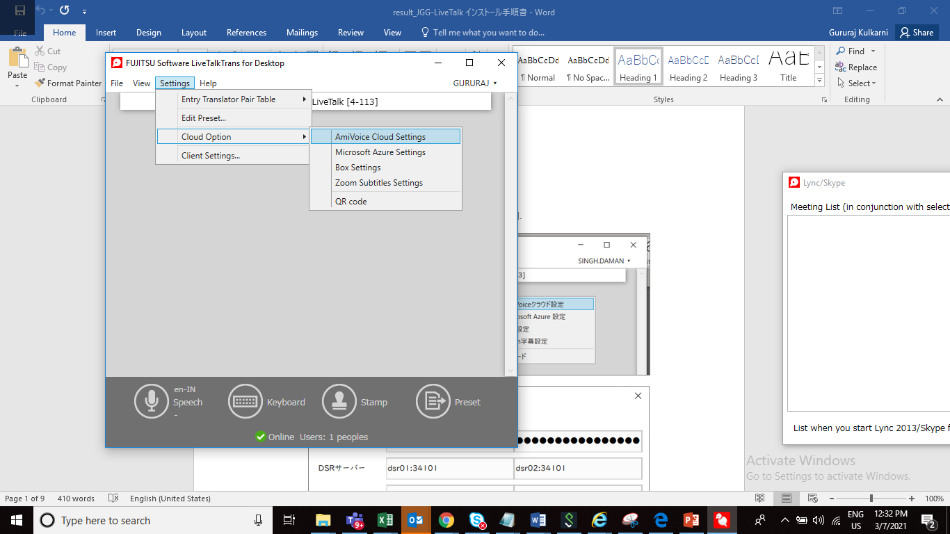

As per license details

As per license details

|  |  |
| --- | --- |
| Service ID | As per your license details |
| Service Password | As per your license details |
| DSR Server | dsr01:34101  dsr02:34101 |
| http server | livetalk-az.amivoice.com:443  livetalk-az.amivoice.com:443 (Same value as above) |

## Step 3: Configure Microsoft Azure

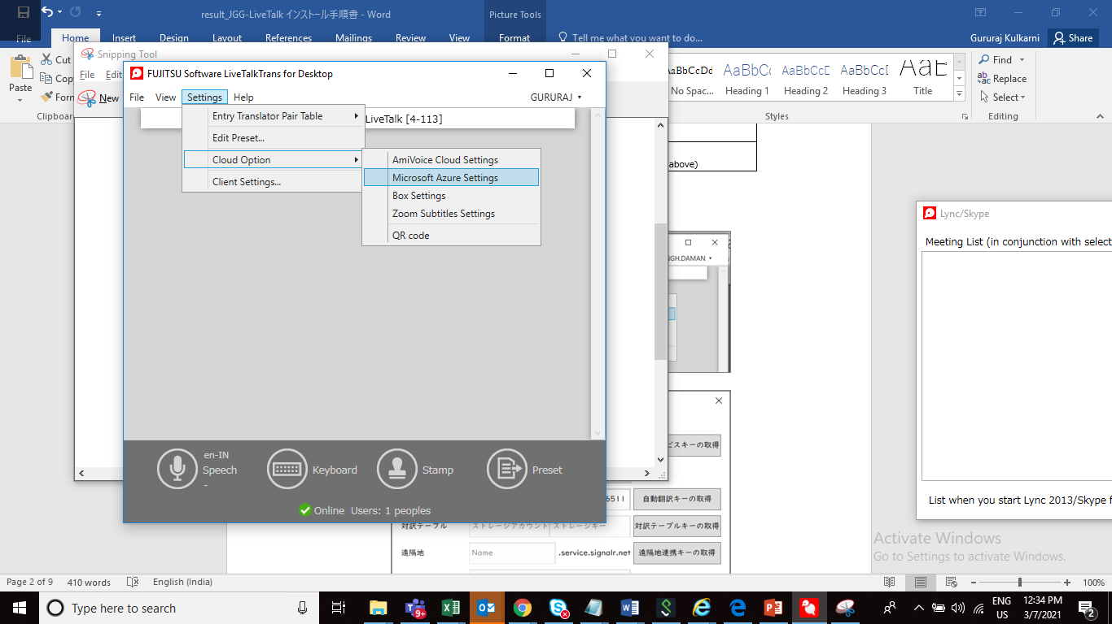

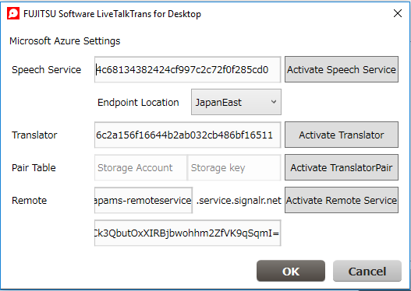

Settings in the LiveTalk menu 🡪 Settings 🡪 Cloud Options 🡪 Microsoft Azure Configuration

Speech services: 4c68134382424cf997c2c72f0f285cd0

Endpoint Location: JapanEast

Translator: 6c2a156f16644b2ab032cb486bf16511

Remote: livetalk-jggsapams-remoteservice

O7fAUrBxFXP4Ck3QbutOxXIRBjbwohhm2ZfVK9qSqmI=

## Step 4: Proxy Settings

Not required for GDC

## Step 5: Select Speech Engine

From the LiveTalk menu 🡪 Settings 🡪 Client settings, configure the following:.

*Japanese speaking terminal

　Speech recognition engine: AmiVoice cloud

　Speech recognition languages: Japanese

　Translation confirmation language: (Same as speech recognition)

　Automated Translation Engine: Microsoft Translation

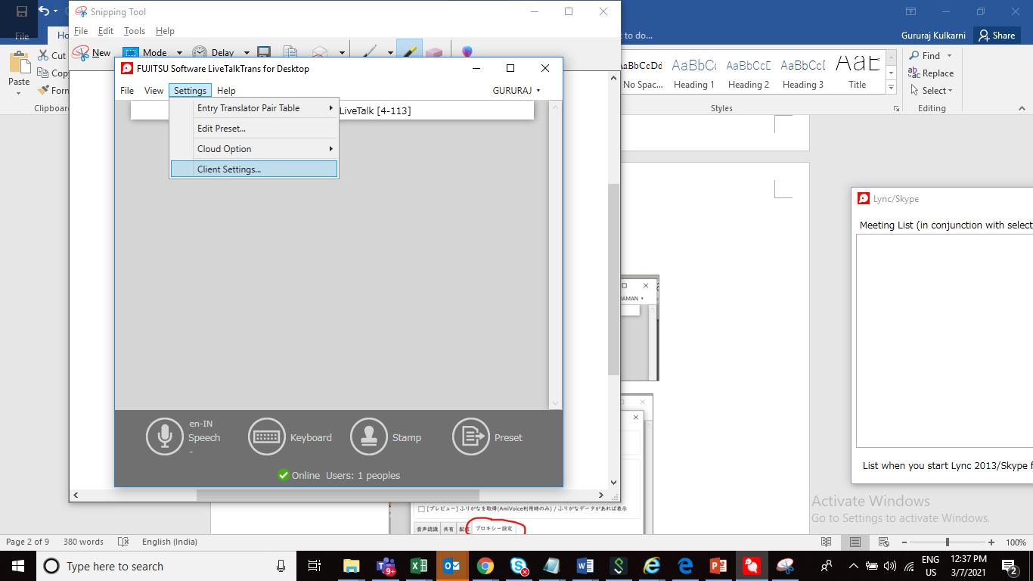

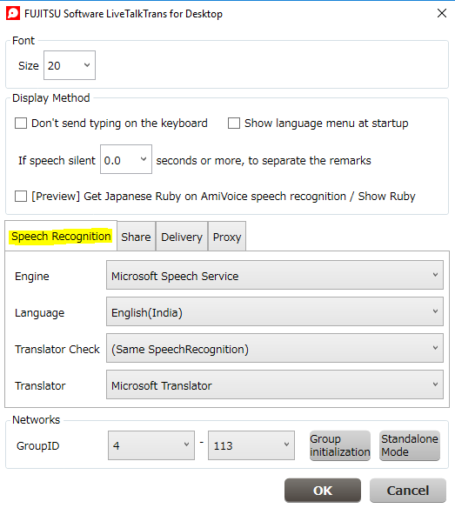

Engine: Microsoft speech services

　Languages: English

　Translation Check: (Same as speech recognition)

　Automated Translation Engine: Microsoft Translator